***Executive Summary***

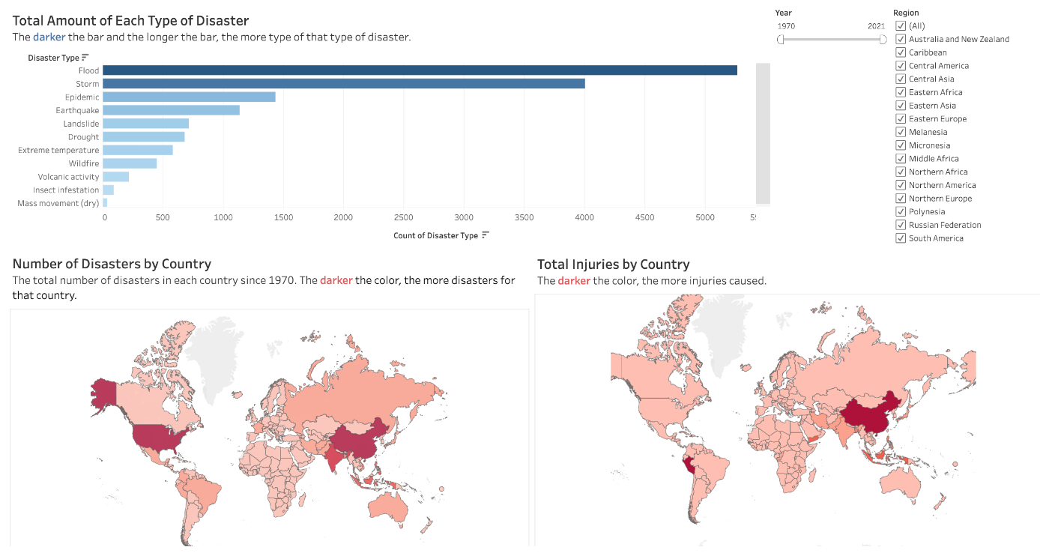

Natural disasters pose significant threats to communities around the world, leading to devastating consequences for affected populations. In order to allocate aid effectively, it is crucial to understand which countries are most vulnerable to these events. In this project we analyzed the different disasters and their effects on different countries. We chose to break the project down into 3 dashboards to allow for the best and easiest analysis possible. Those 3 sections are:

* Disaster Overview: Contains visualizations that allow for analysis of the different types of disasters and their frequencies, number of disasters by country, and total injuries by country.
* Economic Impact: Contains visualizations that allow for analysis of average total damages, average cost of reconstruction, amount of damage caused by each type of disaster, and the trend of number of disasters per year
* Human Impact: Contains visualizations that allow for analysis of deaths by country, average number of injuries, and average homeless population in each country.

We used these three dashboards, and their interactivity features, to analyze and compare the different countries to come to a consensus of what countries are in need of the most aid when a natural disaster occurs.

* Big Idea: Our goal is to provide a clear and compelling portrayal of the country's most vulnerable to and in need of aid due to the impact of natural disasters, thereby enabling targeted and effective allocation of resources for humanitarian relief efforts.

***Basic Information***

Analyzing and Visualizing Global Catastrophic Events

Michael Kapel & Hunter Gibson

***Data***

We utilized a dataset from Kaggle provided at the following [link](https://www.kaggle.com/datasets/brsdincer/all-natural-disasters-19002021-eosdis/data). This dataset was sourced from NASA’s EOSDIS (Earth Observing System Data and Information System) database. This database is designed to manage and distribute Earth science data collected by NASA satellites and other instruments. It is a crucial component of NASA's Earth Science Division, which aims to advance our understanding of Earth as a dynamic, integrated system. The dataset includes 48 columns and 14,645 rows. This data set offers a wide range of information, such as specifics about the kinds of disasters, their locations, their severity, the populations they affect, their economic effects, and other relevant factors.

Before using the dataset, we had to do minimal pre-processing. The only thing that needed changing was in the “Countries” attribute, some of the items had a trailing unnecessary word “the” after the country name. We did this in excel by using the text to column function to break the country names apart from the unnecessary “the” into a separate column and then deleting that column.

***Visualizations***

For our visualizations, we chose to utilize dashboards instead of static visualizations. We made this decision because in order to make the best-informed decision, the target audience will need to be able to look at multiple factors at once and see how they correlate, and a dashboard is the best way to do this.

*Disaster Overview Dashboard*

For our first dashboard, Disaster Overview, we have three visualizations. A bar chart that displays the total amount of times each type of disaster has occurred with the disaster type on the y-axis and count of each item on the x-axis. We chose a bar chart because this the data used in the visualization contains one categorical and one quantitative variable, which is best shown by a bar chart. We chose to keep the design very simple to allow for easy interpretation by the audience. We did, however, choose to add a sequential color filter to the visualization to make the bars colored based on the number of occurrences for each disaster, with the more saturated color representing more occurrences of that disaster. The second visualization we chose to use is a map visualization showing the number of times a disaster has happened in each country. For this visualization we again used a sequential color filter with the more saturated colors representing more disaster occurrences in that country. We chose to use this visualization because it allows for the user to look at how one country compares to those around it in terms how many times a disaster has happened. The third visualization we used is another map visualization showing the total number of injuries that a disaster has caused in that country. We chose to use the map because when placed side by side with the other map visualization showing the number of disasters in each country, it allows for easy analysis of how the number of disasters and the number of injuries correlate. We chose to use the same color hue and saturation as the number of disasters visualization for similarity purposes, since the two visualizations will be used hand in hand during analysis. We incorporated two interactive features for the audience. The first feature is the ability to filter by year. Users are able to use a dragger in the top right corner to adjust the range of years that they want to see the data for. The default is the full dataset, 1970 to 2021. For example, say the user would like to view the data for 2000 through 2010, they would move the left slider to the start year and the right slider to the end year and all three graphs will change to display the data for those years. We chose to incorporate this feature because there could be situations where the user will only want to see data for certain years for analysis. The second feature we incorporated is a filter to only show the data for certain regions. The default is the full dataset showing all regions. For example, say the user would like to only see the data for Northern America and Central America, they could only check the boxes next to those two regions and the visualizations would change to show the data for those regions. We chose to incorporate this feature because it pairs well with the year feature, adding another level of depth that the user has access to, allowing for a deeper analysis.

*Economic Impact Dashboard*

The second dashboard we created is one that shows the economic impact of disasters. The first visualization is a bar chart that displays the countries with the highest average damage cost of disasters. We chose to use a bar chart because the attributes for the data being used contains one categorical and one quantitative, which is best shown by a bar chart. For this chart, we added a sequential color filter by the amount of aid that has been distributed, with a darker saturation representing more aid received for that country. We did this because when paired with the bars, it allows the user to see which countries have the highest average damage costs and how much aid they have received compared to the other countries. The second visualization we included is another bar chart that displays the average amount of damage that each type of disaster has caused. We chose to use this visualization because it allows the user to easily see which disasters are more costly than others. We included a sequential color filter again to add an additional feature that allows for easy interpretation and analysis. The third visualization we used is another bar chart showing the top 10 countries with the highest reconstruction costs. We included this visualization because when paired with the average damage costs visualization it allows for analysis of the correlation between average damage costs and reconstruction costs for each country. The final visualization we included is a line chart showing the trend of the costs of damages caused by natural disasters overtime. We included this visualization because it is helpful for the user to understand how the costs have increased or decreased throughout time so that the proper amount of aid can be distributed based on recent data. For this dashboard we chose to link the visualizations and allow the user to click on one country’s bar in the average damage cost visualization and all other visualizations will filter to show only the data for that country. This allows for the user to dive deeper into a single country and analyze the different attributes.

*Human Impact Dashboard*

The final dashboard we created is one that shows the human impact of disasters. The first visualization we included is a map displaying the total deaths caused by disasters. We created this visualization to allow the users the easily see which countries throughout the world have had the deadliest disasters. We included a sequential color filter similar to the other map visualizations, with a darker saturation representing more deaths. This allows for easy distinction of exactly which countries have had the deadliest disasters. The second visualization we included is a bar chart showing the countries with the highest average homeless population. We chose this visualization because the user may want to see the correlation between average homeless population and total deaths for each country to see is more homeless people leads to more deaths since they do not have a place to shelter in the event of a disaster. The final visualization we created is a line chart showing the trend of the average number of people injured by disasters overtime. We included this visualization because it allows the user to see which years have had the most and least amount of people injured and compare it to deaths and homeless population. For this dashboard we incorporated the ability to filter by year. Users are able to use a dragger in the top right corner to adjust the range of years that they want to see the data for. The default is the full dataset, 1970 to 2021. For example, say the user would like to view the data for 2015 through 2020, they would move the left slider to the start year and the right slider to the end year and all three graphs will change to display the data for those years. We chose to incorporate this feature because there could be situations where the user will only want to see data for certain years for analysis.

***Usage Scenario***

The visualizations can be used during an interactive session in many ways. Users can interact with our disasters overview dashboard by using filtering, sliding, panning, and zooming. We have a filter for region so that you can filter the maps to highlight one region specifically to look at the impact. This is very useful for those who allocate aid analyzing regions specifically and being able to focus in on them without any other highlighting on the map. The slider is a date slider with the year the natural disaster occurred. This allows users to look at the last ten years, for example, to get a better understanding of what countries are currently most affected. The maps are also able to be panned and zoomed to any specific location on the map. This allows users to be able to easily see narrow in on some of the smaller countries and regions allowing for quick insights for aid allocation.

Example of the region and year filter along with pan and zoom of the maps is shown below ↓

On our economic impact slide there is cross-chart filtering giving the user a great contextual understanding. On our visualization showing the countries with highest damage costs each bar representing a country is clickable and can filter the other visualizations on the page. The other visualizations are the average amount of damage caused by each disaster type, the total reconstruction costs, and total damages caused year over year. With cross-filtering you can select a country from the bar chart and see all the visualizations tailored to that country specifically providing a great snapshot of the impact economically.

A before and after filter image is shown below ↓

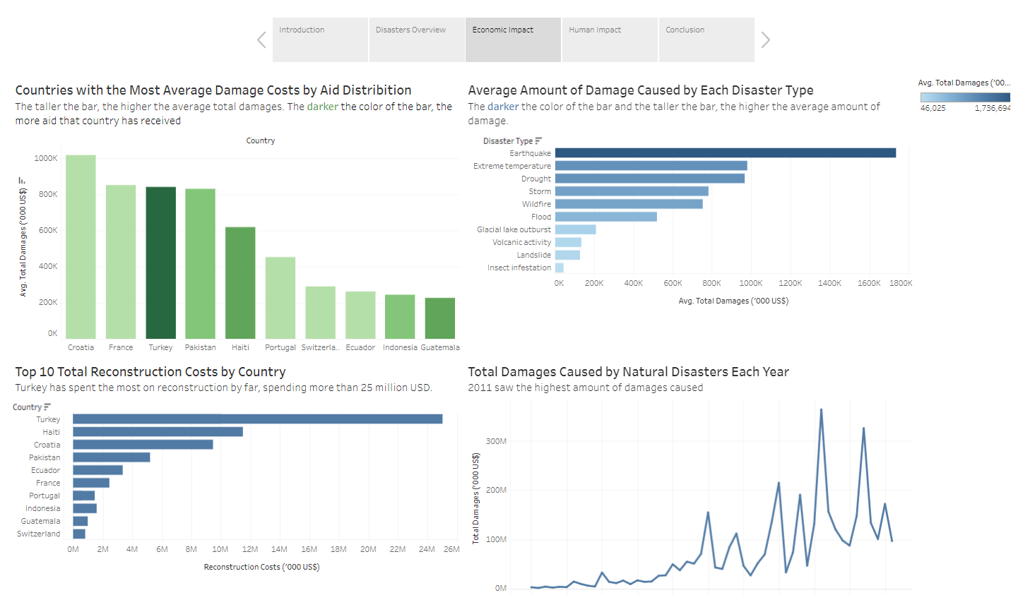

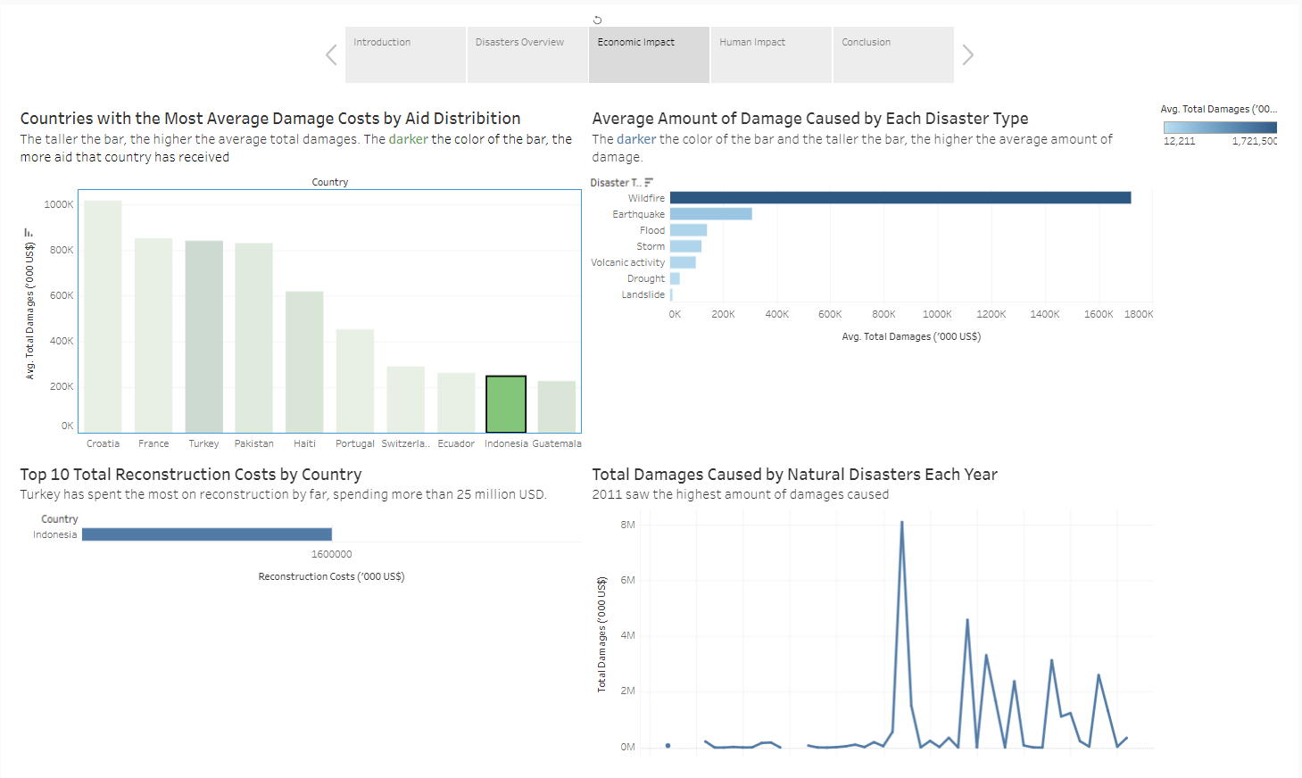

***Reflection***

Overall, the most enjoyable part of creating this story was completing the interactivity. Interactivity adds an interesting element to visuals keeping the audience and users engaged and interested in the topic as charts and maps transform. Seeing this all come together in the end was the most enjoyable as it allows the story to be told fully while having users be able to fully explore the data. The least enjoyable part of creating the story was cleaning the data as many countries had the word “the” before or trailing the name of the country. This is a problem because tableau was not recognizing the country for the countries with this “the” therefore they were grayed out on the maps. We eventually solved this problem using excel to remove this “the”. Our project developed to be more cohesive as time went on through the focus of the story and a greater understanding of the context behind the data we were working with. Our original storyboard was focused on analyzing the trends, factors contributing to vulnerabilities, and risk of natural disasters. The storyboard then began to change and develop as started the analysis and creating visualizations. We had a country level analysis, impact analysis, and vulnerability factors slides within the story. All slides looked good and provided valuable insights, but we soon realized it did not tell the full story. We pivoted from the original storyboard looking back at our big idea which was which countries are most in need of aid. We then thought about what factors are most important to be able to come to this conclusion.

The focus was then on these three questions:

1. What is the frequency and severity of natural disasters for each country?

2. What is the economic impact for each country?

3. What is the human impact for each country?

Focusing on these three categories gave the viewer an understanding of the natural disasters themselves, how the economy was affected, and how human life was affected. This framework is what we decided to use for the final presentation. We made visualizations that aligned with each category and when all were analyzed together allowed us to come to a final conclusion. Not only did we now have valuable insights, but the story was able to be told as well through the questions being answered, interactivity, and visualizations themselves. We completed this project using Tableau and given our original proposal and the goals we wanted to achieve we felt this software was more than capable. However, there was something we attempted to show that was not able to be figured out. We wanted to incorporate an animated piece showing the maps and line graphs changing over time once you clicked play. The animation would be based on the year and unfortunately did not work as planned with the line graphs not giving the effect we were going for. This was partly do too how the data was structured and not all countries having lots of data on certain disasters or during certain periods of time. We then decided to keep the visualizations the way they were if the animation did not add a level of value to the overall story. If we were to do this project again, we could add an AI summary to each page by using PowerBI. We could use the smart narrative feature in PowerBI to summarize the key takeaways from each page no matter the region or time frame that is filtered for the page. This way the user is given a summary automatically generated for them which is backed up by the visualizations shown.

***Project Management & Team Assessment***

|  |  |  |  |  |
| --- | --- | --- | --- | --- |
| **Task** | **Time estimate** | **Actual time** | **Assigned to** | **Date Completed** |
| Project Proposal | 1.5 hours | 1.75 hours | Hunter, Michael | 11.02.2023 |
| Project Update I | 1 hour | 50 min | Hunter, Michael | 11.08.2023 |
| Project Update II | 1 hour | 50 min | Hunter, Michael | 11.28.2023 |
| Presentation Prep | 1 hour | 50 min | Hunter, Michael | 12.04.2023 |
| Recorded Video | 1 hour | 45 min | Hunter, Michael | 12.05.2023 |
| Written Report | 3 hours | 2.5 hours | Hunter, Michael | 12.08.2023 |
| Total | 8.5 hours | 5 hours |  |  |

**Project Proposal:**

Hunter – Introduction, Data, Big Idea

Michael - Storyboard, Visualizations, Team Communication Plan

**Project Update I:**

Hunter – Data, Big Idea, Usage Scenario, Reflection, Credits

Michael – Storyboard, Visualizations, Project Management & Team Assessment

**Project Update II:**

Hunter – Data, Big Idea, Usage Scenario, Reflection, Credits

Michael – Storyboard, Visualizations, Project Management & Team Assessment

**Recorded Video:**

Hunter – Introduction, Disaster Overview

Michael – Economic Impact, Human Impact, Conclusion

**Written Report:**

Hunter – Usage Scenario, Reflection, Project Management & Team Assessment, Credits

Michael – Executive Summary, Basic Info, Data, Visualizations

***Credits***

We relied on tableau specifically for this project as we felt it was the best way to tell our story. The storyboard feature allowed us to really think about what story we wanted to tell on each slide. The dashboard feature made it very easy to pull visuals together and create a meaningful and interactive group of visuals to our story. The map visualization and its features also helped inspire different ways we could display the data and with our data being geographic helped us tell the full story.

***Works Cited***

Dincer, Baris. “All Natural Disasters 1900-2021 / Eosdis.” Kaggle, 10 Oct. 2021, [www.kaggle.com/datasets/brsdincer/all-natural-disasters-19002021-eosdis/data](http://www.kaggle.com/datasets/brsdincer/all-natural-disasters-19002021-eosdis/data).

Earth Science Data Systems, NASA. “Earth Observing System Data and Information System (EOSDIS).” NASA, NASA, 3 May 2019, [www.earthdata.nasa.gov/eosdis](http://www.earthdata.nasa.gov/eosdis).

“Our Leadership.” Front Page, [www.unocha.org/our-leadership](http://www.unocha.org/our-leadership).